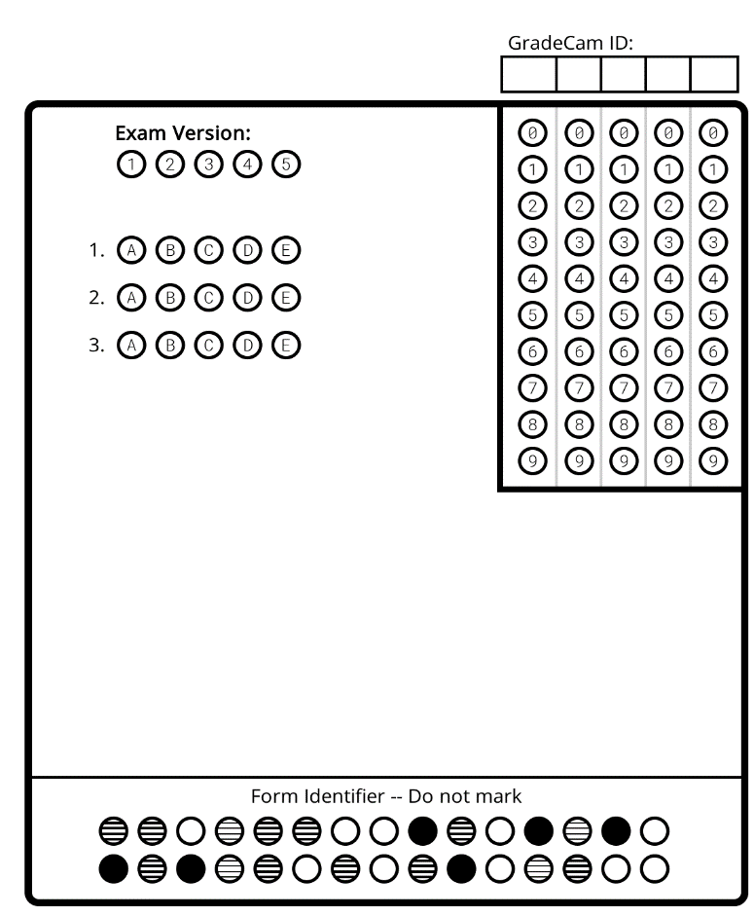
Waves: Day 6 Name: _________________________________ Core: _______ Date: ___Tuesday, March 28th
Learning Check!
1. What type of wave are EM waves?
A) Longitudinal B) Transverse C) Mechanical
2. These EM waves have the longest wavelength:
A) Radio B) X-rays C) Visible Light
3. This wave is used to transmit signals to and from your cell phone:
A) Radio B) Visible Light C) Microwaves

VOCABULARY:
1. ________________ the distance between crests of a transverse wave or compressions of a longitudinal wave.
2. ________________ These are emitted from the sun and are dangerous to humans because of their high energy.
3. ________________ Anything with a temperature above absolute value will emit these waves.
4. ________________ The only part of the EM spectrum humans can actually see.
5. ________________ What we refer to all of the EM waves as when they are in order of wavelength and energy.

Spectrum * Infra-red * Ultra Violet (UV) * Visible Light * Wavelength

- Infra-Red:  - Anything with a __________________ above absolute zero will emit Infra-Red waves.  - Certain censors can detect _____________ emitted by the body.  - They can be used by the _______________ to see suspects at night or by the ________ ____________ to locate people in smoke-filled buildings.  - Infra-red light is often used for ______________ __________ communications.  - Uses [list at least 2]: __________________________________________________________  - Visible Light:  - This relatively narrow band of the spectrum is the only part humans can ______________.  - Different ___________________ correspond to different colors. If all of the wavelengths of visible light are being emitted, we see the combination as a ________________ light. | - Visible Light (continued):  - When the temperature of an object gets above 500 degrees C, it starts to emit in the _______________ as well as the infra-red and we see it glowing _________ _______.  - Uses [list at least 2]: ____________________________________________________  - Ultra Violet:  - At this end of the spectrum the waves become extremely ______________ to living organisms. The waves have enough ___________ to ionize the atoms, disrupt the DNA which can lead to cancer.  - The __________ and other white hot objects emit some UV light as well as visible light. Fortunately the ________________ protects us from most of it but what little gets to the ground is enough to give us a sub-burn.  - Uses: ________________________________________________________________

