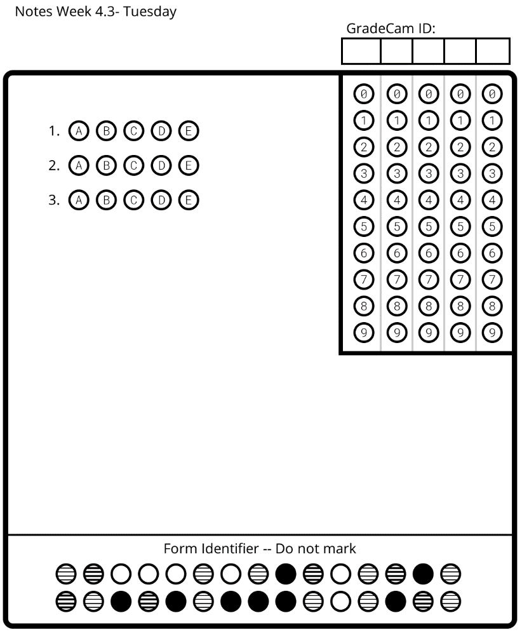
Waves: Day 10 Name: ____________________ Core: ____ Date: __Tuesday, April 4th______
Tomorrow’s Learning Check will be graded!!
Learning Check:
1. What is it called when a wave bounces back off of a barrier? A) Refraction B) Reflection C) Absorption
2. When you look at a glass with a straw in it from the side, what causes the straw to look bent?
A) Reflection B) Transmission C) Refraction
3. If you cannot see light at all through an object, we call it:
A) Transparent B) Opaque C) Translucent

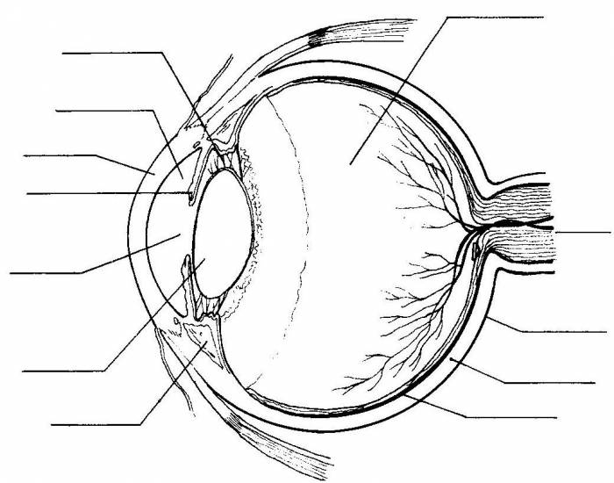
Diagram of the Eye

Vocabulary
1. _____________ Clear covering over the eye.
2. __________ Circular band that controls how much light enters the eye.
3. __________ Tissue that bends (refracts) light passing through and helps focus an image.
4. __________ hole in the center of the eye which allows light to pass through.
5. ___________ white part of the eye; protects the eye
6. ___________ layer of tissue on the back of the eye that has cone and rod cells which gather information.
7. __________: allow us to see black, white, and shades of grey
8. ___________: allow us to see red, blue, and green colors
9. ____________: nerve that connects the eye to the brain
10. ___________ & __________: cover & protect the eye
11. ____________ __________: allow eyes to move

How do we see?

1. Light waves are _________________ from a light source.
2. The light waves hit an object. Some of the light is __________________, and only whatever color is seen is _______________________.
3. Light enters the eye through the __________________.
4. Light continues through the ____________ which is controlled by the ___________________.
5. Light passes through the lens which __________________ (bends) the light causing the picture to be upside down.
6. The upside down picture is received by the rods and cones of the ___________________.
7. The _____________ _______________ sends signals to the _________________ which flips and interprets the image.

