Name _________________
Date __________________
Core ______Period ______

Mass-_________________________________________________________

________________________________________________________________

Volume-__________________________________________________________

________________________________________________________________

Matter is anything that has ____________ and____________________.

The universe is full of _______________.

Matter is made of _____________.

There are more than _________ elements that combine to make up all living and
nonliving things.

Elements are shown on a ______________________.

Matter is composed of extremely small particles called ___________.

These particles are too ____________ to be seen with a microscope.

Atoms have all the properties of matter: __________ and _____________

Atoms are the smallest part of an ______________

All atoms of the same element have the same ________________

If an atom is the basic particle from which all elements are made, why don't we have a Periodic Table of the Atoms, instead of Periodic Table of the Elements?
Name _________________
Date __________________
Core ______Period ______

Mass-

Volume-

Matter is anything that has ____________ and____________________.

The universe is full of _______________.

Matter is made of _____________.

There are more than _________ elements that combine to make up all living and
nonliving things.

Elements are shown on a ______________________.

Matter is composed of extremely small particles called ___________.

These particles are too ____________ to be seen with a microscope.

Atoms have all the properties of matter: __________ and _____________

Atoms are the smallest part of an ______________

All atoms of the same element have the same ________________

If an atom is the basic particle from which all elements are made, why don't we have a Periodic Table of the Atoms, instead of Periodic Table of the Elements?

Matter is anything that has mass and volume. The entire universe is composed of matter, which is in turn composed of atoms. An atom is the basic building block of all matter. All matter in the universe, from a teaspoon of salt to the Pacific Ocean, has mass and occupies space. The salt and ocean, however, have very different properties and behaviors. Since everything in the universe is composed of matter, there are clearly many types of matter.

Elements: Names and Symbols
Everything, from ants to galaxies, is composed of atoms. So far, scientists have discovered or created 118 different types of atoms. Scientists have given a name to each different type of element and organized them into a chart called the periodic table. As you can see in the table below, each square contains one of the elements.
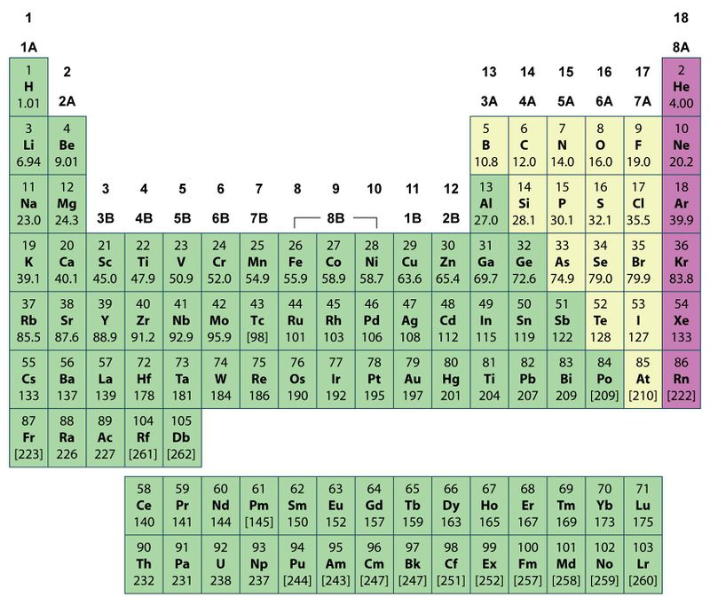

Each element not only has its own name, it also has its own symbol. Scientists use abbreviations called chemical symbols to represent the elements. Many of these symbols are the first one or two letters of the modern name of the element. The first letter of a chemical symbol must always be a capital letter, and the second letter, when there is a second letter, must always be a lowercase letter.

