**Liquid Layers Lab**

**Hypothesis**: If you pour vegetable oil, honey, dish soap, and water in a beaker then ______________________ will form the topmost layer and _________________ will form the bottom layer because each liquid has a different ______________.

**Data:**

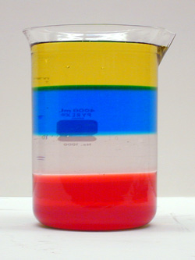

**Liquid Layers Diagram**

**Questions:**

**1.** Why do the liquids in this system float on top of each other in the order that they do?

### ______________________________________________________________________________

### ______________________________________________________________________________

2. What is density? ______________________________________________________________

______________________________________________________________________________

3. Which liquid do you think is the densest? Which is the least dense? _____________________

______________________________________________________________________________

4. What is the relationship between the density of a liquid and its position in the beaker?

______________________________________________________________________________

5. The liquids in this experiment model how Earth’s layers separated into four different layers according to their densities.

B

AD

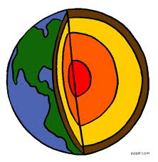

This diagram shows Earth’s different layers.

C

Answer the questions based on this diagram:

D

a. Layer _______ has the greatest density.



b. Layer __________ has the least density.

6. Describe the similarities and differences between the liquid layers model and the structure of Earth’s layers. _________________________________________________________________

______________________________________________________________________________

______________________________________________________________________________

**7.** Which layer of Earth does each liquid in this system represent? ________________________

______________________________________________________________________________

______________________________________________________________________________

**Conclusion:**

a. Was your hypothesis correct? ___________________________________________________

b. Explain briefly how you came up with your hypothesis. _______________________________

______________________________________________________________________________

c. Stir up the liquids with the tongue depressor. Wait for a few minutes and look again. What happened? ____________________________________________________________________

______________________________________________________________________________